Programmatically adding controls:

How many values in the form at runtime?

Create a loop to do this

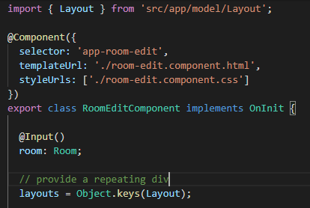

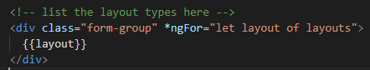

Test it

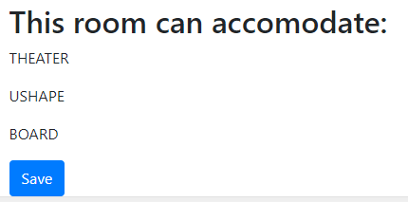

Now, all for numeric inputs per room type:

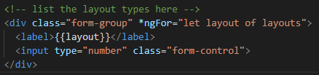

Test it

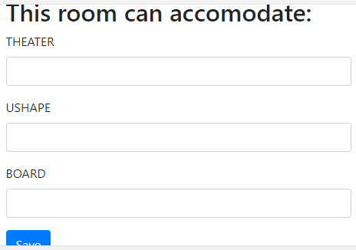

Let us fix the label output

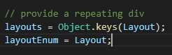

Now, use the layoutEnum to get to the text of the enum

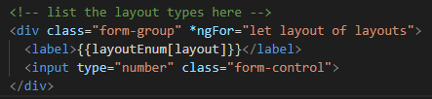

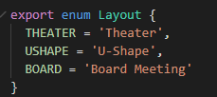

Test it

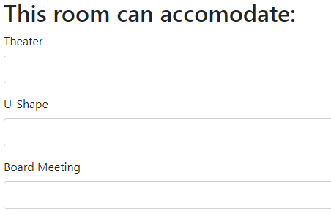

Add the id value

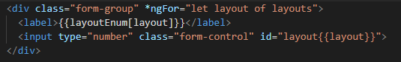

Test in the console

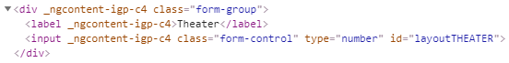

This gives us an id for the label as well

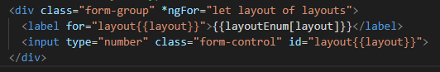

Check this

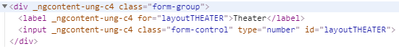

Now, we can tab through the labels correctly

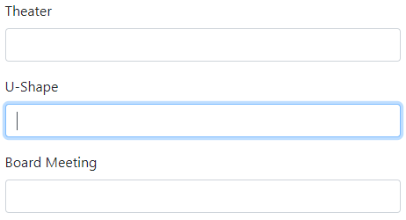

Let us add the formControlName

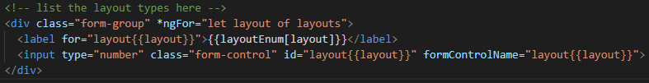

Dynamically add elements to the room-edit.component.ts file

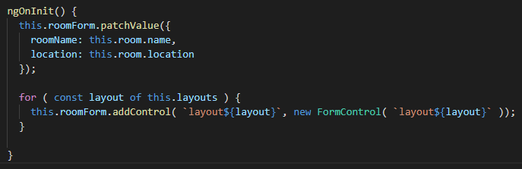

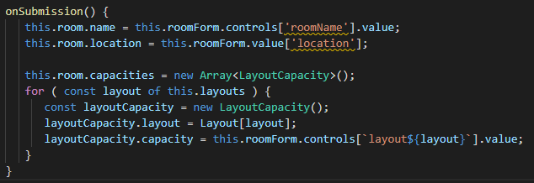

Let us a console.log to test this

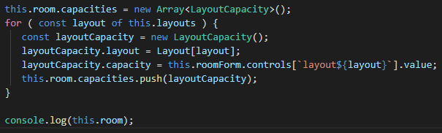

Test it Add 2, 4, 6 and save

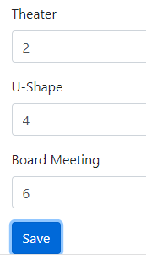

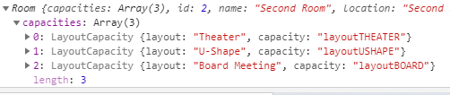

Error the capacity is of type number and is outputting a string - the values should be 2, 4, 6

and not layoutTHEATER, layoutUSHAPE, layoutBOARD

Fix: Moved the [formGroup] into the form on both Name and Location:

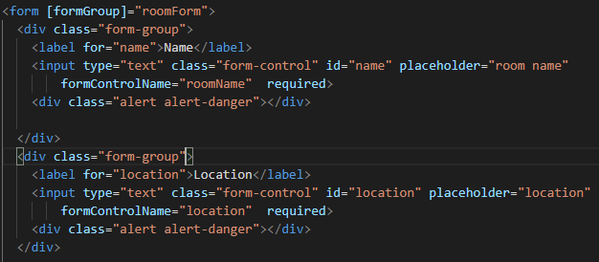

Now, it works!

